MACH4METAL

metalworking machinery
Transito 21
6909 DA BABBERICH Netherlands
Tel. +31 (0)316-247123
Fax: +31 (0)316-247956
info@mach4metal.com
www.mach4metal.com

Bank No : 66.52.13.883
IBAN : NL33 INGB 0665 2138 83
BIC : INGBNL2A

Pressbrake EASY FORM 2500 x 80 T
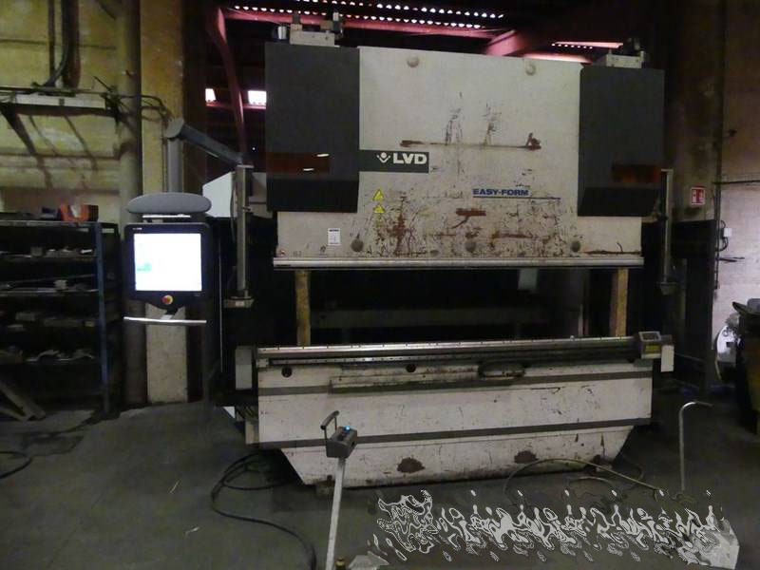

- Make : LVD Belgium
- Typ : PPEB 80-25 EASYFORM
- Mach. No. : 33703
- Age : 2010

- Max. pressure : 80 T
- Max. bending length : 2.500 mm
- Dis. between column : 2.050 mm

- Stroke : 200
- Dis. table – ram : 400
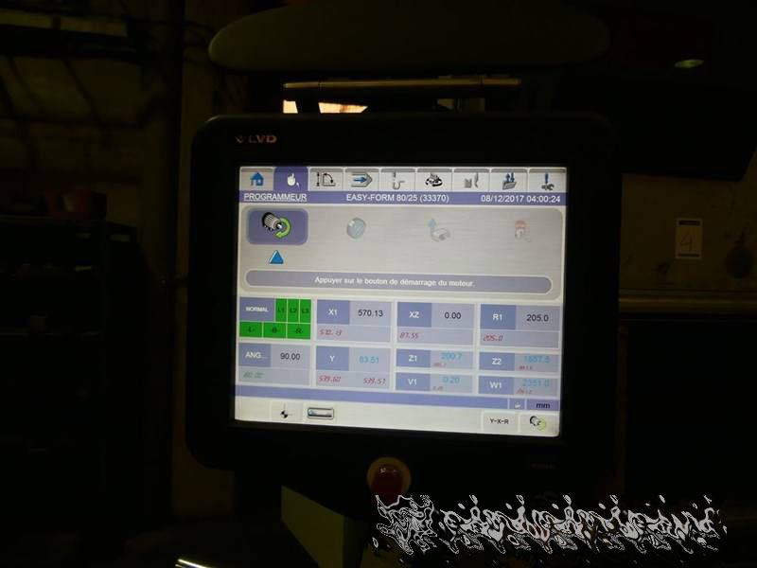
- Throat : 400
- Table width : 120

- Approch speeds : 130 mm/M
- Working speeds : 10 mm/M
- Return speeds : 120 mm/M

- Cadman TOUCH CNC with X 600 mm
- X¹ / R / Z¹ / Z²
- EFL EASYFORM System
- CNC V – Axis Crowning
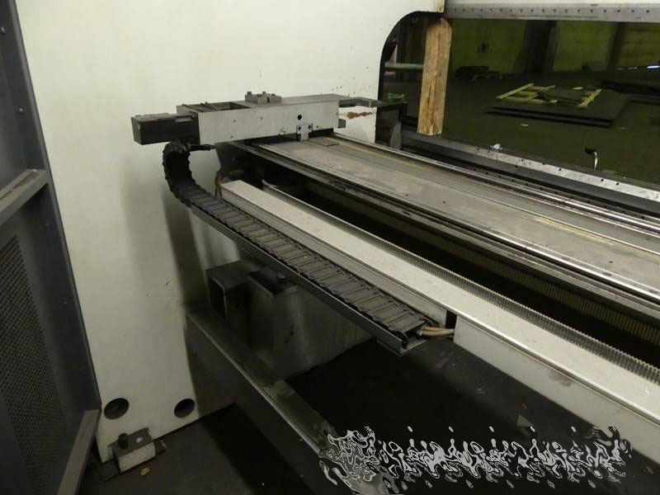
- WILA New Standard clamping

- Dimensions
- Length : 3.350
- Width : 1.900
- Height : 2.700
- Weight : 6.500

Please Note: The above information has been obtained to the best of our ability and belief from, and from the manufacturers where possible. It is given in good faith, but its accuracy can not be guaranteed. Accordingly, it will not form a representation or constitute contractual terms. We advise you to check any vital details!

